**Claromentis PHP Developer Test Task**

The task is to run some calculations and display results based on data from an uploaded CSV file. CSV stands for comma separated values – a format supported by Excel or any other spreadsheets software.

The source data is an imaginary expenses report and the goal of the programme is to display total cost per expense category.

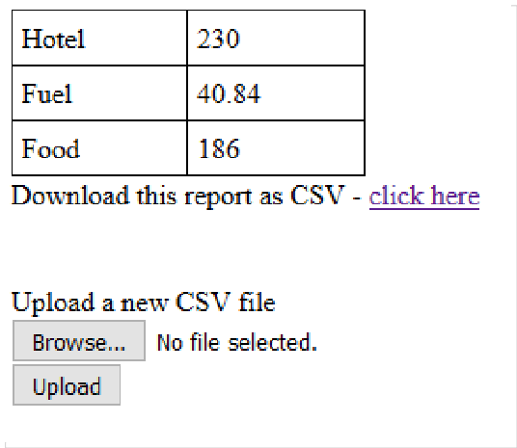

Once the summary data has been calculated and displayed, it should be possible to generate and download a report CSV file with the same data as displayed in the table.

An example of a possible page layout is shown on the screenshot, but how you lay it out is up to you.

**File format**: the expected source file does not have any headers, and contains the following three columns:

* **category**. String. May be one of a few values, not defined in advance (the set of available values can be different in different CSV files)
* **price**. Numeric. Cost per item
* **amount**. Numeric. Number of items

Example file in Excel: Plain text:

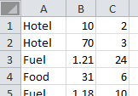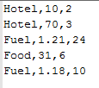

Assume that the tool will be public and used by multiple users, so consider privacy/security. The resulting pages must be fully valid XHTML or HTML5. Please send the result as an archive with all required files, maintaining the folder structure. Include instructions in a readme file at the root of the archive. Do not use any frameworks for the application. It's fine to use 3rd party libraries, if needed.

The test is not just about giving the correct output, but is more an opportunity for you to show us your knowledge and skills, feel free to over-engineer to show off.